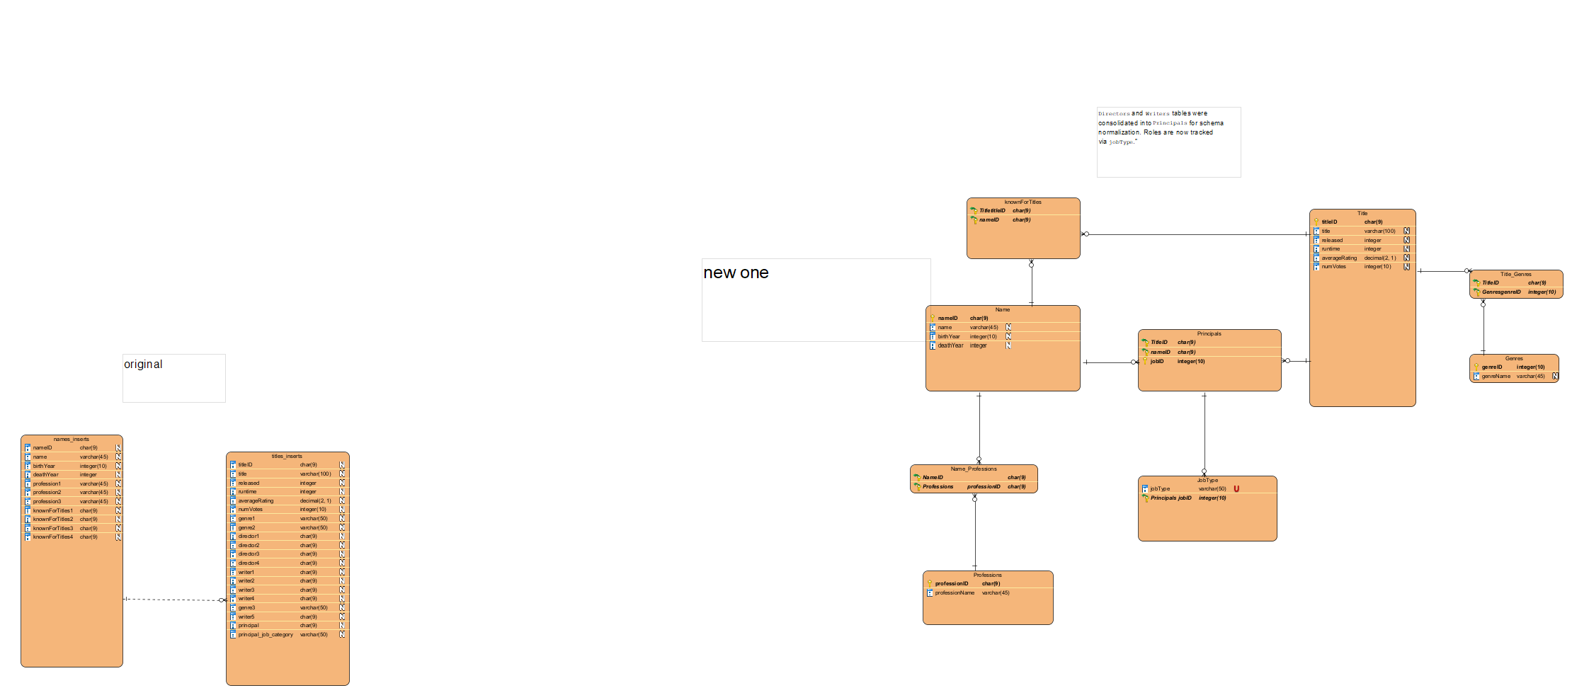

A big and immediate red flag is that structured relational databases are very rarely going to have two entities linked directly to each other. This is not how scalable, normalized schemas are designed. In the current implementation, the titles and names tables are separate with no intermediary structure. This demonstrates a lack of foresight in the schema design, and the system has now reached a stage where the absence of normalization directly compromises data integrity.
The many-to-many relationship between people and titles is mishandled. One person can be associated with many titles, and one title can involve many people. This should be represented with a bridging table, but no such table exists. As a result, relationships are not being tracked explicitly. Running a query to count how many titleIDs appear in the titles table but not in any nameID entry from the names table revealed 4972 unmatched entries. That figure indicates the schema is not reliably associating people with works, leaving a substantial number of records orphaned.
While the database avoids inter-row duplication, there is a large amount of intra-column duplication in the names table. The use of profession1, profession2, and profession3 columns is a clear violation of First Normal Form. These columns are an attempt to store multivalued data by expanding the schema horizontally, which is fundamentally flawed. A query checking how many rows have nulls in any of those three columns returned 20,950 affected records. This confirms that the current structure is not only non-scalable but also inefficient, as it leads to sparse data and awkward query patterns.
Any time a schema uses fixed columns to store dynamic data like professions, it signals either a misunderstanding or a disregard for normalization. The problems are not just theoretical: query complexity increases, indexing becomes less effective, and the schema becomes brittle in the face of future data requirements. If a person has more than three professions, there is no way to represent that without altering the schema itself—an unmaintainable situation.
A further issue is that the schema does not explicitly model job roles or relationships between people and titles. There is no concept of roles such as actor, director, or writer represented in a relational way. These associations are either implied or embedded in unstructured form. This design eliminates the ability to perform even basic analytic tasks like listing all directors or aggregating ratings by cinematographer. Such queries require workarounds or hardcoded logic, which defeats the purpose of using a relational model in the first place.
Finally, the schema lacks foreign key constraints, which explains why referential integrity has been lost. Without keys, the system permits orphaned records and breaks logical consistency. This makes the database behave more like a collection of spreadsheets than a structured, enforceable system.
The most urgent and foundational fix is to introduce a linking table between names and titles, with an additional column to record each person’s role. This would properly model the many-to-many relationship and restore relational integrity. Additional bridge tables should also be used for dynamic attributes such as profession. Once normalized to at least third normal form, the schema will become cleaner, more performant, and easier to query for any serious analysis.

